Art and Drama: Creativity and Pain
- 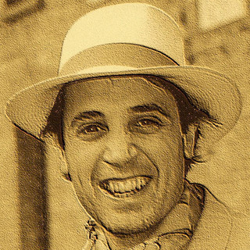
Manuel Puig
- Dec 19, 2019

Van Gogh
Van Gogh started painting at the age of 27, and the most significant works were created over the last two years of life. He had the tendency to focus on self-portraits, landscapes, still-lifes of flowers, paintings with cypresses, representation of wheat fields, and sunflowers. It is known to many that Vincent Van Gogh was mentally ill. Epileptic seizures, depression, hallucinations, and anxieties made him totally unable to work. He spent a period of his life in an asylum, and he finally attempted suicide in July 1890 by shooting himself with a revolver in the chest. He failed in his intent, yet he died after two days of agony.

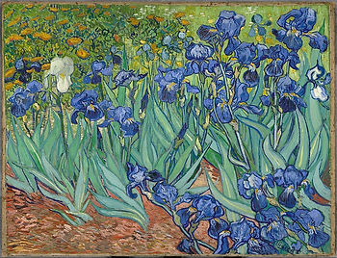
Irises, 1889

Chaim Soutine
He instinctively painted still-lifes and portraits, but above all, it was landscapes that inspired his anguished emotions and vibrant lyrical shots. These works were among the first to interest collectors, and he gained relative economic tranquility. Soutine never officially joined any artistic current; although, because of his passionate use of vivid colors, he is considered one of the most remarkable representatives of Expressionism due to his highly personal vision and pictorial technique. From 1930 to death, he rarely showed his works and tried to deepen his existential and formal research with dramatic results. Obsessed with form and color and often depressed and unsatisfied, Soutine destroyed many of his works in times of hiw own psychological crisis.

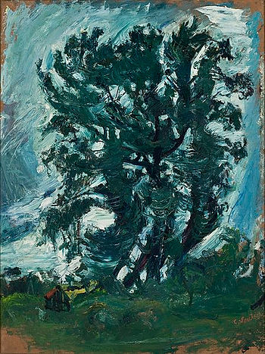
The big Tree, 1942

Séraphine Louis
Orphaned at an early age, Séraphine Louis was sent to service at the age of 10. Sèraphine, after years spent in the convent (of which, in the years of the asylum, denounced violence and abuse), in 1906 he moved to Senlis. Deeply religious, she began to paint at 42 claiming that the angels told her to do so. Séraphine, which has become obsessed by her creations, gradually lost her mind as she became a recognized painter. Obsessed by inner voices, she begun to wander the city streets inable to be understood and taken in care, until she was interned in a mental hospital in February 1932. She was buried in a mass grave in 1942.

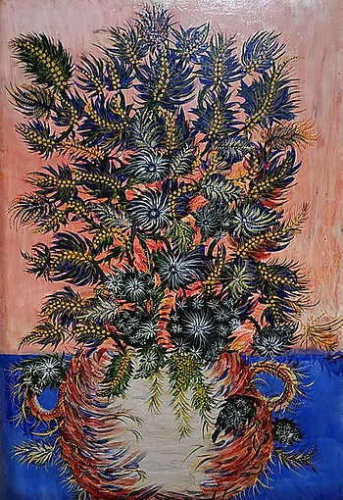
Le bouquet de mimosa, 1932

Atom Hovhanesyan (Hovhannisyan)
Always passionate about visual arts, Atom began a full-time painting career in 2009, at the age of 27. His focus and attention address anatomy, perspective, color theory, art history, and the Old Masters of the past. He attended the Art Students League of New York and the National Academy of New York. While appreciating the continuum of change in his work, Hovhanesyan’s art remains grounded in a very simple geometric component: the line. Straight or delicately curved, Hovhanesyan’s juxtaposition of innumerable linear strokes serve to build up images in oil, ink, or even pen, transcending media and serving as a very personal form of expression. Atom Hovhanesyan (his father last name is Hovhannisyan, but due to a wrong translation from the Armenian, he was known as Hovhanesyan), created over 200 pieces of art before losing his battle with depression in May 2018.

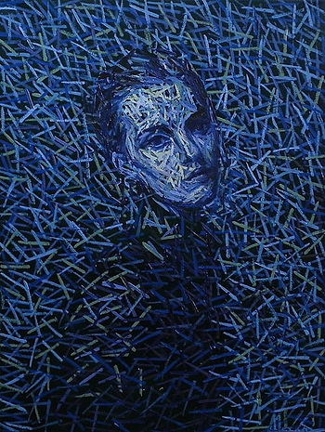
No Title, 2018

Edvard Munch
Edvard Munch is one of the most acclaimed Norwegian painters of the twentieth century. He suffered from serious depression that fueled his deep melancholy.
Munch's entire life was marked by pain and suffering from both illness and family problems. Death was a constant in his life. His mother and one of his sisters died of tuberculosis, and the other sister died in a psychiatric hospital, where she had been interned because of schizophrenia.
His best-known work, The Scream series, represents universal anguish strong enough to change the whole perception of the universe around the protagonist who, in a solitary agony, cannot express his own pain, which is indifferent to the rest of humanity until it is released—exploded in a scream.

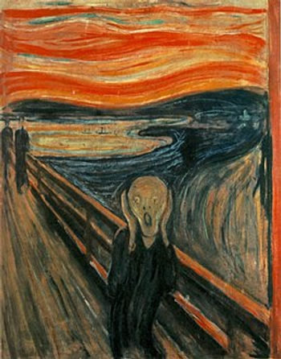
The Scream, 1893 - 1910
William Kurelek
Kurelek was born near Whitford, Alberta in Canada, and he was the oldest of seven children in a family of Ukrainian immigrants. He developed an interest in art, which his parents—struggling immigrant workers—didn’t encourage. He later studied at the Ontario College of Art and at the Inende Allende in Mexico. In 1952, suffering from depression and emotional problems, he had a stay at the Maudley Psychiatric Hospital in England. Then, he was diagnosed with schizophrenia. In the hospital, he practiced his art, paintings mostly. His experience in the hospital was documented in the Time-Life The Mind book, which was published in 1965. He returned to Toronto and produced a series of classic children's books that included his work. He died in 1977 from cancer.

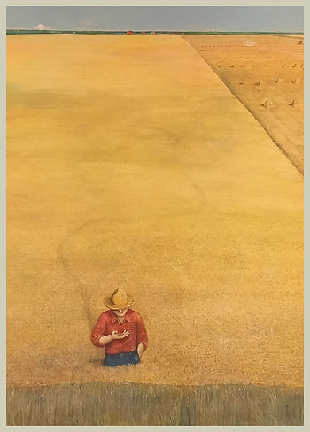
The Ukrainian Pioneer, 1971-1976

Karl Wilhelm Diefenbach Diefenbach was a pioneer of nudism and the pacifist movement. The commune he founded in Vienna, active between 1897 and 1899, was one of the models for the settlement of Monte Verità in Ascona. He pursued ideals of social reform by professing a complex of ideas, which included living life in harmony with nature, the refusal of monogamy, alienation from any religion (although he was a follower of theosophy), and the practice of a vegetarian diet. When his municipality went bankrupt, he moved to the island of Capri, where he spent the rest of his life.

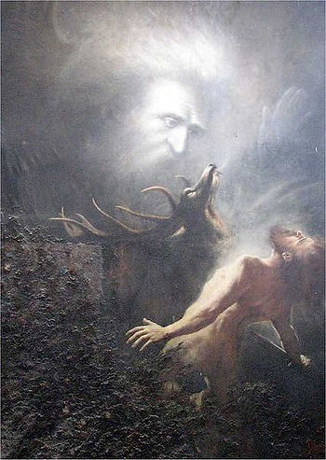
Du sollst nicht töten, 1903

